**THE RAT MAZE RUNNER**

**A MINI PROJECT REPORT**

**18CSC36IJ- Design and Analysis of Algorithms**

*Submitted by*

**Bhavya Jha [RA2011042010029]**

**Lakshmi Vibha [RA2011042010039]**

**Eshita Mishra [RA2011042010062]**

*Under the guidance of*

**Dr. Prabhu Kavin B**

Assistant Professor, Department of Data Science and Business Systems

***In Partial Fulfillment of the Requirements for the Degree of***

**BACHELOR OF TECHNOLOGY**

**in**

**COMPUTER SCIENCE ENGINEERING**

**with specialization in Computer Science and Business Systems**



**DEPARTMENT OF DATA SCIENCE AND BUSINESS SYSTEMS COLLEGE OF ENGINEERING AND TECHNOLOGY SRM INSTITUTE OF SCIENCE AND TECHNOLOGY**

**KATTANKULATHUR- 603203**



**SRM INSTITUTE OF SCIENCE AND TECHNOLOGY KATTANKULATHUR – 603203**

**BONAFIDE CERTIFICATE**

Certified that this mini project report titled “Rat Maze Runner” is the bonafide work done by Bhavya Jha (RA2011042010029), Lakshmi Vibha (RA2011042010039) and Eshita Mishra (RA2011042010062) who carried out the mini project work and Laboratory exercises under my supervision for **18CSC361J -Design and Analysis of Algorithms**. Certified further, that to the best of my knowledge the work reported herein does not form part of any other work.

| **Dr. Prabhu Kavin B**  **ASSISTANT PROFESSOR**  **18CSC361J -Design and Analysis of Algorithms**  **Course Faculty**  Department of Data Science and Business Systems |  |
| --- | --- |

**Signature of the Internal Examiner-I Signature of the Internal Examiner-II**

# **INDEX**

Contents

BONAFIDE CERTIFICATE 2

INDEX 3

Abstract 4

Problem Statement & Objectives 5

Objectives 6

Solving Rat in Maze Problem 7

Backtracking 7

State Space Tree 7

Backtracking Algorithm 8

Using Backtracking Algorithm 9

CODE 11

1. **CONCLUSION 15**
2. **REFERENCES** **16**
3. **APPENDICES 17**

# Abstract

You may remember the maze game from childhood where a player starts from one place and ends up at another destination via a series of steps. This game is also known as the rat maze problem. This is a very classic problem and can be mind bending to solve. You might have seen the same problem on the pencil boxes back in fourth grade, only that there was no rat but a bearing ball instead and the goal was probably to push the ball into a small cauldron.

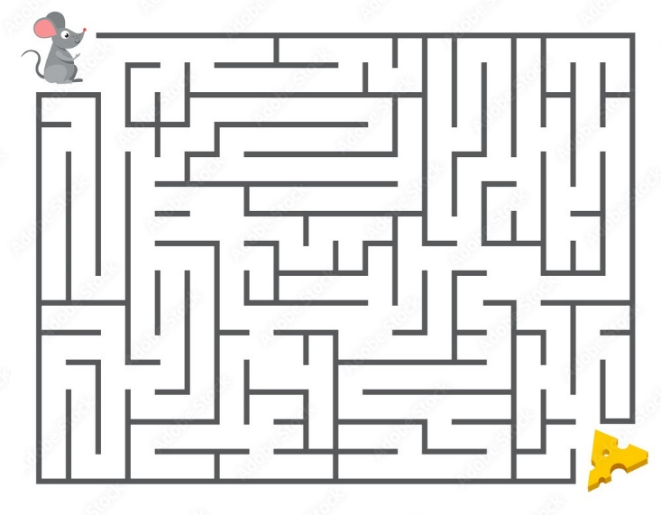

# **Problem Statement & Objectives**

A maze is in the form of a 2D matrix in which some cells/blocks are blocked. One of the cells is termed as a source cell, from where we have to start. And another one of them is termed as a destination cell, where we have to reach. We have to find a path from the source to the destination without moving into any of the blocked cells. A picture of an unsolved maze is shown below, where grey cells denote the dead ends and white cells denote the cells which can be accessed.

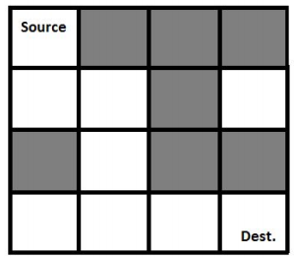

### **Objectives**

A rat starts at a position (**source**)and can only move in two directions:

1. Forward
2. Down

The goal is to reach the destination using these steps.

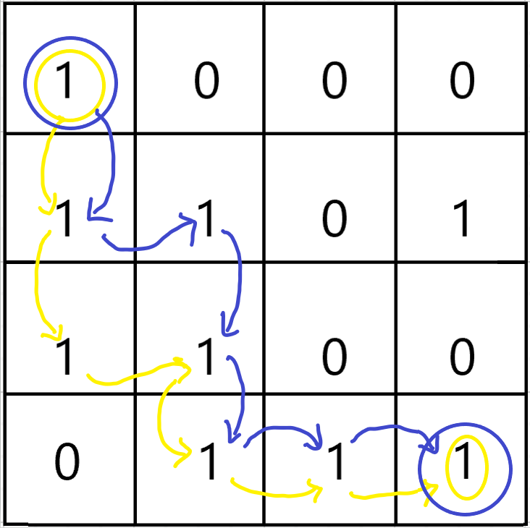

# **Solving Rat in Maze Problem**

# **Backtracking**

A backtracking algorithm is a problem-solving algorithm that uses a **brute force approach** for finding the desired output.

The term backtracking suggests that if the current solution is not suitable, then backtrack and try other solutions. Thus, recursion is used in this approach.

This approach is used to solve problems that have multiple solutions.

## **State Space Tree**

A space state tree is a tree representing all the possible states (solution or nonsolution) of the problem from the root as an initial state to the leaf as a terminal state

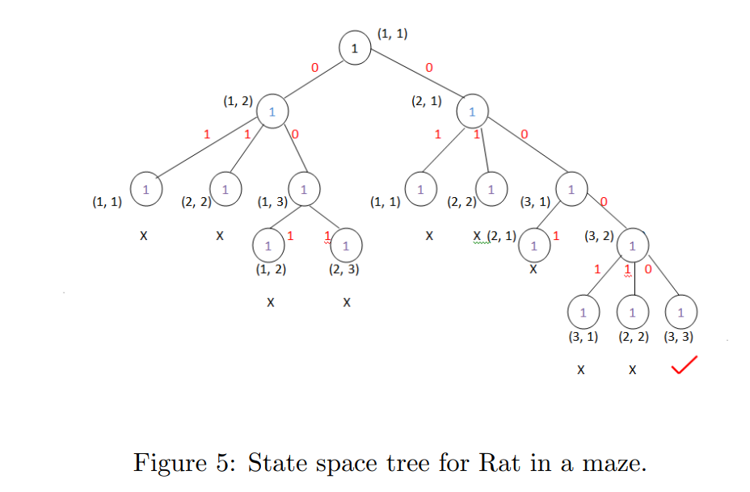

## **Backtracking Algorithm**

Backtrack(x)

if x is not a solution

return false

if x is a new solution

add to list of solutions

backtrack(expand x)

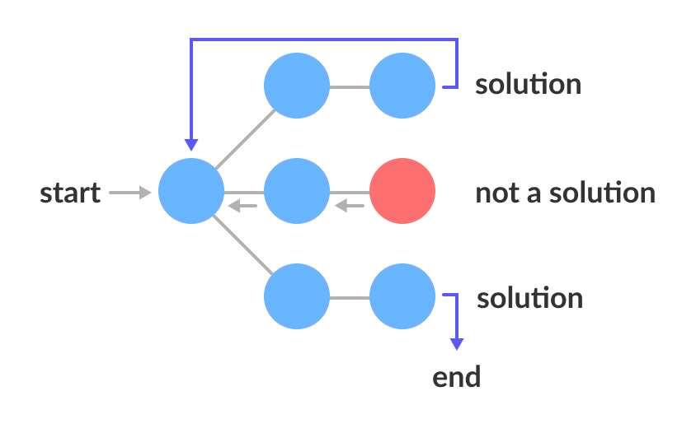

# **Using Backtracking Algorithm**

**Approach:**

Initially, we will push a node with indexes i=0, j=0 and dir=0 into the stack. We will move to all the direction of the topmost node one by one in an anti-clockwise manner and each time as we try out a new path we will push that node (block of the maze) in the stack. We will increase dir variable of the topmost node each time so that we can try a new direction each time unless all the directions are explored ie. dir=4. If dir equals to 4 we will pop that node from the stack that means we are retracting one step back to the path where we came from.  
We will also maintain a visited matrix which will maintain which blocks of the maze are already used in the path or in other words present in the stack. While trying out any direction we will also check if the block of the maze is not a dead end and is not out of the maze too.  
We will do this while either the topmost node coordinates become equal to the food’s coordinates that means we have reached the food or the stack becomes empty which means that there is no possible path to reach the food.

**Algorithm**

* Create a solution matrix, initially filled with 0’s.
* Create a recursive function, which takes initial matrix, output matrix and position of rat (i, j).
* If the position is out of the matrix or the position is not valid then return.
* Mark the position output[i][j] as 1 and check if the current position is destination or not. If destination is reached print the output matrix and return.
* Recursively call for position (i-1,j), (I,j-1), (i+1, j) and (i, j+1).
* Unmark position (i, j), i.e output[i][j] = 0.

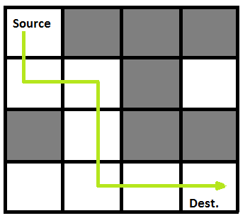

**Example Input:**

Following is a binary matrix representation of the above maze. Where 1 represent open path and 0 represent blockage

Grid:

{{1, 0, 0, 0}

{1, 1, 0, 1}

{0, 1, 0, 0}

{1, 1, 1, 1}}

**Output:**

Following is the solution matrix (output of program) for the above input matrix.

{1, 0, 0, 0}

{1, 1, 0, 0}

{0, 1, 0, 0}

{0, 1, 1, 1} All entries in solution path are marked as 1.

# CODE

// C++ program to solve Rat in a Maze problem using

// backtracking

#include <stdio.h>

#include <stdbool.h>

// Maze size

#define N 4

bool solveMazeUtil(int maze[N][N], int x, int y,int sol[N][N]);

// A utility function to print solution matrix sol[N][N]

void printSolution(int sol[N][N])

{

for (int i = 0; i < N; i++) {

for (int j = 0; j < N; j++)

printf(" %d ", sol[i][j]);

printf("\n");

}

}

// A utility function to check if x, y is valid index for

// N*N maze

bool isSafe(int maze[N][N], int x, int y)

{

// if (x, y outside maze) return false

if (x >= 0 && x < N && y >= 0 && y < N && maze[x][y] == 1)

return true;

return false;

}

// This function solves the Maze problem using Backtracking.

/* It mainly uses solveMazeUtil() to solve the problem. Itreturns false if no path is possible, otherwise return*/

// true and prints the path in the form of 1s. Please note

// that there may be more than one solutions, this function

// prints one of the feasible solutions.

bool solveMaze(int maze[N][N])

{

int sol[N][N] = { { 0, 0, 0, 0 },

{ 0, 0, 0, 0 },

{ 0, 0, 0, 0 },

{ 0, 0, 0, 0 } };

if (solveMazeUtil(maze, 0, 0, sol) == false) {

printf("Solution doesn't exist");

return false;

}

printSolution(sol);

return true;

}

// A recursive utility function to solve Maze problem

bool solveMazeUtil(int maze[N][N], int x, int y, int sol[N][N])

{

// if (x, y is goal) return true

if (x == N - 1 && y == N - 1 && maze[x][y] == 1) {

sol[x][y] = 1;

return true;

}

// Check if maze[x][y] is valid

if (isSafe(maze, x, y) == true) {

// Check if the current block is already part of

// solution path.

if (sol[x][y] == 1)

return false;

// mark x, y as part of solution path

sol[x][y] = 1;

/* Move forward in x direction */

if (solveMazeUtil(maze, x + 1, y, sol) == true)

return true;

// If moving in x direction doesn't give solution

// then Move down in y direction

if (solveMazeUtil(maze, x, y + 1, sol) == true)

return true;

// If none of the above movements work then

// BACKTRACK: unmark x, y as part of solution path

sol[x][y] = 0;

return false;

}

return false;

}

// driver program to test above function

int main()

{

int maze[N][N] = { { 1, 0, 0, 0 },

{ 1, 1, 0, 1 },

{ 0, 1, 0, 0 },

{ 1, 1, 1, 1 } };

printf("\n\nOUTPUT/SOLUTION PATH\n\n");

solveMaze(maze);

printf("\n\nThe 1 values show the path for rat\n\n");

return 0;

}

**OUTPUT:**

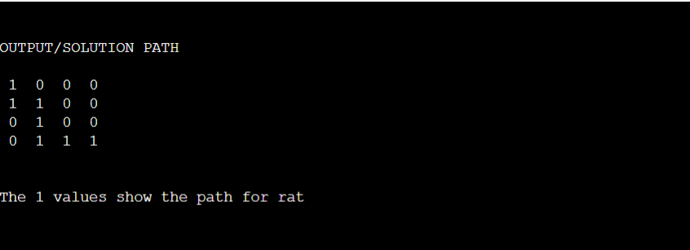

**COMPLEXITY ANALYSIS:**

* Time Complexity: O(2^(n^2)).   
  The recursion can run upper-bound 2^(n^2) times.
* Space Complexity: O(n^2).   
  Output matrix is required so an extra space of size n*n is needed.

**Conclusions**



**References**

1. https://www.geeksforgeeks.org/rat-in-a-maze-backtracking-2/
2. <https://www.codingninjas.com/blog/2020/09/02/backtracking-rat-in-a-maze/>
3. https://kshriya1996.medium.com/surfing-puzzles-with-backtracking-52b557b06107

**APPENDIX:**

